

Foundations of Programming

Assignment No. : 06
PROBLEM STATEMENT:Write a C function to compute the factorial of a number with and without recursion.

OBJECTIVE:

To demonstrate two different approaches for calculating the factorial of a number: iterative (non-recursive) and recursive, showcasing the versatility of problem-solving methods in programming.

THEORY:
- Explain the difference between the iterative and recursive approaches to calculating the factorial of a number.
- What is the base case in the recursive function for computing factorials, and why is it necessary?
- How does the program handle invalid input, such as negative numbers, and why is this important?
PLATFORM: Linux
ALGO:
Step 1: Start
Step 2: Input n
Step 3: Call factorial(n)
Step 4: In factorial(n):
If n == 0 or n == 1, return 1
Else return n * factorial(n - 1)
Step 5: Print result
Step 6: Stop
FLOWCHART:
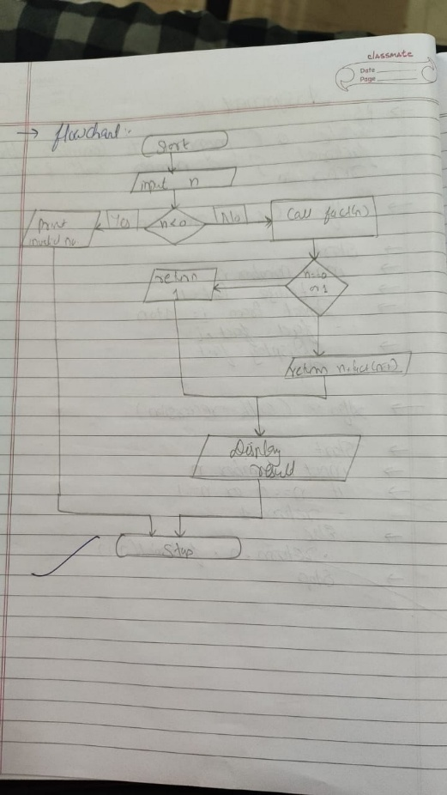

CODE:
#include <stdio.h>

Iterative
long iterFactorial(int n) {
long fact = 1;
for (int i = 1; i <= n; i++)
fact *= i;
return fact;
}

Recursive
long recFactorial(int n) {
if (n == 0 || n == 1)
return 1;
return n * recFactorial(n - 1);
}

int main() {
int n;
printf("Enter a number: ");
scanf("%d", &n);

if (n < 0) {
printf("Invalid input.\n");
return 1;
}

printf("Iterative Factorial = %ld\n", iterFactorial(n));
printf("Recursive Factorial = %ld\n", recFactorial(n));

return 0;
}
INPUT:
OUTPUT:
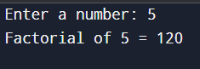
CONCLUSION: Thus, we have successfully executed factorial of a number with and without recursion.

FAQs:
1. What is the purpose of calculating factorial in programming?
2. What is the difference between recursive and non-recursive (iterative) methods?

